Improved REE Sorption from Geothermal Brine Simulants Using Degassed Media and Brine

The purpose of this work is to compare REE sorption from simulated geothermal brine at 70ºC that has been degassed and not degassed. The media removed 71% more REEs from the brine when degassed than not degassed during the 4 hour shaker test. Detailed examination of the specific REEs behavior demonstrated identical sorption characteristics and comparable total removal rates.
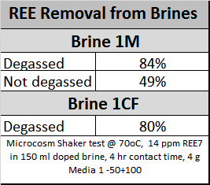

A second study compared the media sorption of REEs in a column format using degassed media and brine to media and brine that was not degassed. The REEs were stripped with acid following the sorption. The bulk of the REEs stripped eluted just after the first void volume of strip acid was introduced to the column. The equivalent column without degassing eluted the REEs at nearly 2 column volumes.
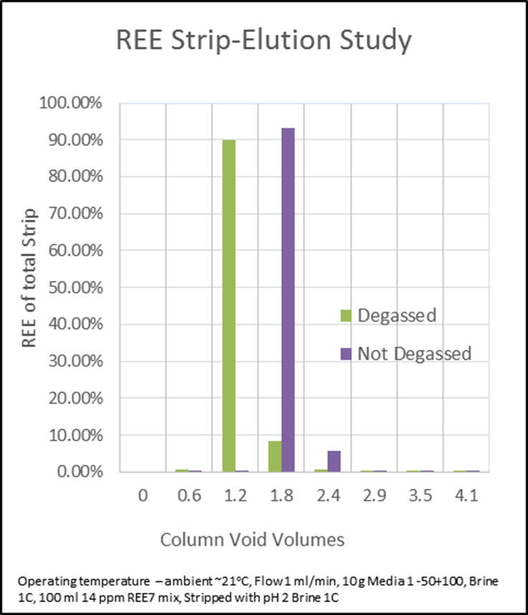

Degassed media and brine improved the amount of REEs that could be sorbed by media in a batch shaker test and improved the sorption and stripping of the REEs from brine in a column sorption experiment.

